

**Green University of Bangladesh**

**Department of Computer Science and Engineering (CSE)**

**Faculty of Sciences and Engineering**

**Semester: (Spring, Year:2021), B.Sc. in CSE (Day)**

**LAB REPORT NO: 01**

**Course Title: : Introduction to Expression in C**

**Course Code: CSE 104 Section: D8**

**Lab Experiment Name: Introduction to Expression in C**

**Student Details**

|  |  |  |
| --- | --- | --- |
| **Name** | | **ID** |
| **1.** | Jahidul Islam | 221002504 |
| **2.** |  |  |
| **3.** |  |  |

**Lab Date : 28/06/2022**

**Submission Date : 07/07/2022**

**Course Teacher’s Name : Mr. Mozdaher Abdul Quader**

**[For Teachers use only: Don’t Write Anything inside this box]**

|  |
| --- |
| **Lab Report Status**  **Marks: ………………………………… Signature:.....................**  **Comments:.............................................. Date:..............................** |

**TITLE OF THE LAB EXPERIMENT**

Calculating Area of a Square.

**OBJECTIVES/AIM [1]**

**We will be able to calculate the area of a Square taking an input from the user.**

**PROCEDURE / ANALYSIS / DESIGN [2]**

If one side of the square is r then the area will be Area = R*R

**IMPLEMENTATION [2]**

I designed the program in 5 section and separated them using multiline comment.

**TEST RESULT / OUTPUT [2]**

**Code 01:**

**1 #include <stdio.h>**

**2 int main()**

**3 {**

**4 /* Program introduction */**

**5 printf("This program takes one integer input to calculate Area of Square.\n\n");**

**6**

**7 /* required variables*/**

**8 int area, side;**

**9**

**10 /* required input */**

**11 printf("Enter the length of the Side: ");**

**12 scanf("%d", &side);**

**13**

**14 /* calculation */**

**15 area = side * side;**

**16**

**17 /* output section */**

**18 printf("The Area of the Square is: %d\n", area);**

**19 return 0;**

**20 }**

**Code 02:**

**1 #include <stdio.h>**

**2**

**3 int main()**

**4 {**

**5 /* program introduction */**

**6 printf("This program converts temperature from Celcius to Fahrenheit.\n");**

**7 printf("It accepts float value.\n");**

**8**

**9 /* required variables*/**

**10 float celsius, fahrenheit;**

**11**

**12 /* required input */**

**13 printf("\nEnter temperature in Celsius scale: ");**

**14 scanf("%f", &celsius);**

**15**

**16 /* calculation */**

**17 fahrenheit = (celsius * 9/5) + 32;**

**18**

**19**

**20 /* output section */**

**21 printf("Temperature in Fahrenheit scale is: %.2fÂ°F\n", fahrenheit);**

**22 return 0;**

**23**

**24 }**

**Code 03:**

**1 #include <stdio.h>**

**2 int main()**

**3 {**

**4 /* program introduction */**

**5 printf("This program converts temperature from Fahrenheit(Â°F) to Celsius(Â°C).\n");**

**6 printf("It accepts float value.\n");**

**7**

**8 /* required variables*/**

**9 float celsius, fahrenheit;**

**10**

**11 /* required input */**

**12 printf("\nEnter temperature in Fahrenheit scale: ");**

**13 scanf("%f", &fahrenheit);**

**14**

**15 /* calculation */**

**16 celsius=(fahrenheit - 32) * 5/9;**

**17**

**18 /* output section */**

**19 printf("Temperature in Celsius scale is: %.2fÂ°C\n", celsius);**

**20 return 0;**

**21 }**

**Code 04:**

**1 #include <stdio.h>**

**2 int main()**

**3 {**

**4 /* program introduction */**

**5 printf("This program takes five subjects and calculate total and average marks.\n");**

**6 printf("It accepts float value.\n");**

**7**

**8 /* required variables*/**

**9 float sub1, sub2, sub3, sub4, sub5, average, total;**

**10**

**11 /* required input */**

**12 printf("Enter Marks in 1st subject: ");**

**13 scanf("%f", &sub1);**

**14 printf("Enter Marks in 2nd subject: ");**

**15 scanf("%f", &sub2);**

**16 printf("Enter Marks in 3rd subject: ");**

**17 scanf("%f", &sub3);**

**18 printf("Enter Marks in 4th subject: ");**

**19 scanf("%f", &sub4);**

**20 printf("Enter Marks in 5th subject: ");**

**21 scanf("%f", &sub5);**

**22**

**23 /* calculation */**

**24 total = sub1 + sub2 + sub3 + sub4 + sub5;**

**25 average = total/5;**

**26**

**27 /* output section */**

**28 printf("\nTotal obtained marks: %.2f\n", total);**

**29 printf("\nAverage marks of Five subjects: %.2f", average);**

**30 return 0;**

**31 }**

**Output 01:**

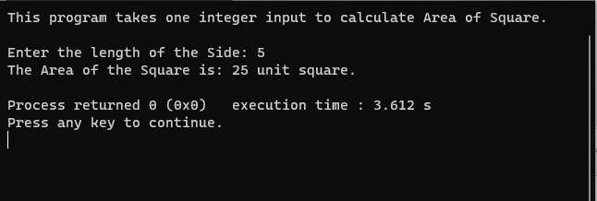

**Output 02:**

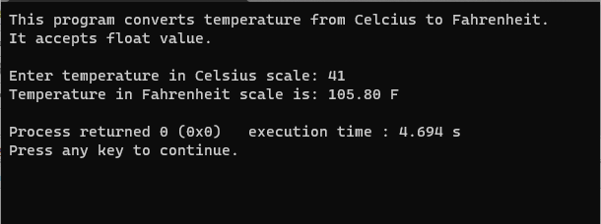

**Output 03:**

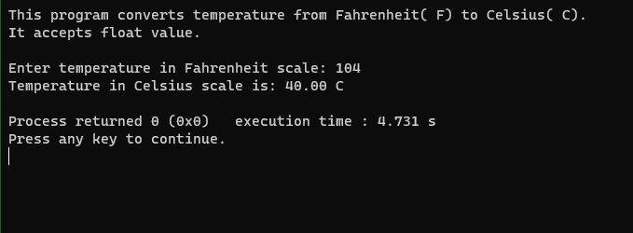

**Output 04:**

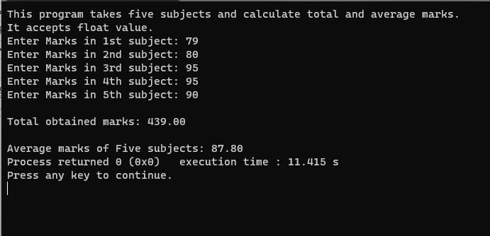

**6. ANALYSIS AND DISCUSSION [2]**

This program outputs area in integer number. It runs well. The trouble spot of this problem is at declaring variable where it only required two variables for perfectly calculating the area.